Dynamic Difficulty Adjustment - Research
Daniel Kočan, student number: 231789

Introduction
DDA (Dynamic Difficulty Adjustment) is an AI-based system that allows the change of attributes and behaviours within the game in runtime. DDA measure the player performance and change the game difficulty to match the player skills. As a result, it creates the challenge used to guide the player into the flow zone.
While using a single difficulty level is an option, it doesn't accommodate every player. A solution could be to allow the player to choose a difficulty level. However, this method also has some drawbacks, such as having a limited set of difficulty levels, creating gaps where players can fall, and having difficulty progression that mismatches player learning curves.
A good DDA must be able to track the player skill level and adapt to it. A DDA system that fulfils these requirements can increase the player confidence in his chances to beat the game when presented with a hard challenge and the core engagement of the player, resulting in an increased gameplay duration.
The goal of this research will be to create a DDA system for Unreal Engine 5.4 that will be usable across different game genres, with an interface, adjustable settings, and data collection.

State-of-the-Art
Where Has It Already Been Used?
- Zanac: An early example of difficulty balancing, the game featured a unique adaptive artificial intelligence, in which the game automatically adjusted the difficulty level according to the player's skill level, rate of fire, and the ship's current defensive status/capability.
- Crash Bandicoot: The first Crash Bandicoot game make use of a "Dynamic Difficulty Adjustment" system, slowing down obstacles, giving extra hit points and adding continue points according to the player's number of deaths.
- Resident Evil 4: This game employed a system called the "Difficulty Scale", unknown to players. This system grades the player's performance on a number scale from 1 to 10 and adjusts both enemy behaviour/attacks used, and enemy damage/resistance based on the player's performance (such as deaths, critical attacks, etc.).
- Mario Kart series: features items during races that help an individual driver get ahead of their opponents. These items are distributed based on a driver's position in a way that is an example of dynamic game difficulty balancing.
How Is DDA Normally Done?
There are many approaches to implement it, with the main difference being the method used to change the attributes and behaviours of the game. The proposed structure is separated into two main parts, measuring the player proficiency and adjusting the game, accordingly, using the method preferred by the developer.
- Measuring the player skill level: This is done by comparing the current in game value of this variables with their expected value. Through a set of predefined variables, it’s possible to assess if the difficulty is fit for the player. To choose the variables used to evaluate the player performance it is important to have a clear notion of what is considered as a failure, a success or a skill that the player needs to develop within the game. A good example is given in Pac-Man. By measuring the number of hits on the maze walls, the number of keys pressed and the number of direction switches, it is possible to have an idea of what the player skills are.
- Adjusting the game: At the start of the game, there is no data of the player performance, and so, the developer must set the difficulty based on the average testing results. Then, the game must quickly adapt to the player performance. Afterward, the change of difficulty should happen less often and be smaller, allowing for the growth of the player skills. Changing the value of attributes in the game is the first and most intuitive of the modifications to be done, and the easiest of them. Secondly, Traits in a game can be presented not only as attributes but also as behaviours. Events provide an alternative that doesn’t required too many modifications to the existing game codebase, as does the change in attributes and behaviours.
More details on how it could work can be found on my Miro table: LINK.
What Are Unsolved Problems?
- DDA is still a new field of research, and much can be done to increase its effect on player engagement. New methods for implementation are always needed.
- The creation of tools that allow easy DDA implementation for all game styles and that can be used in the most popular frameworks or engines for game development, such as Unity or Unreal, is a field that is still untouched.
- The concept of predicting a player's skill level based on external factors, such as age and frequency of playing video games, presents a significant opportunity for enhancing DDA. Integrating such predictive models could allow for more personalized difficulty adjustments from the start.
Reflection: DDA is a powerful tool that allows adjusting game difficulty according to player experience, and it's a possibility because many popular games are already using it. Researching these games provides a better understanding of how the system should work, but creating a complete system for it remains a major task. Next time, I should also spend time researching how to create a proper system, as it's an entirely new topic.

Proof of Concept
Beginning of development process and problems:
Firstly, I began investigating Unreal Engine and its tools. To create a system for Unreal Engine, I had to develop my own C++ blueprint. After following several guides and encountering some fascinating problems, I came up with a solution. The easiest approach was to create a separate ‘AInfo’ class and use it for Unreal Engine to extract data from the world. This class could include settings for Dynamic Difficulty Adjustment (DDA).
The main problem was the absence of an existing system for this purpose, so I had to come up with my own ideas and design. Since every game handle difficulty changes differently, I used that as a reference point. I needed to determine the metrics for measuring player skill, how to evaluate player progress in real-time, and what aspects of the game should change with difficulty adjustments. Since various game genres differ, I decided that designers should establish the game difficulty levels and what changes with each level. My role was to implement the functionality to allow for easy usage.
I came up with the idea to store data that should be considered and create functions that could be easily connected to blueprints to automatically evaluate player progress. I will create different available functions that will get information from DDA, which could be used in the code (for example, if the game difficulty is hard, allow enemies to use more advanced combos, etc.). This allows the variables to be adjusted depending on DDA, rather than being predetermined. Moreover, it allows DDA to change certain aspects of the game while leaving others untouched.
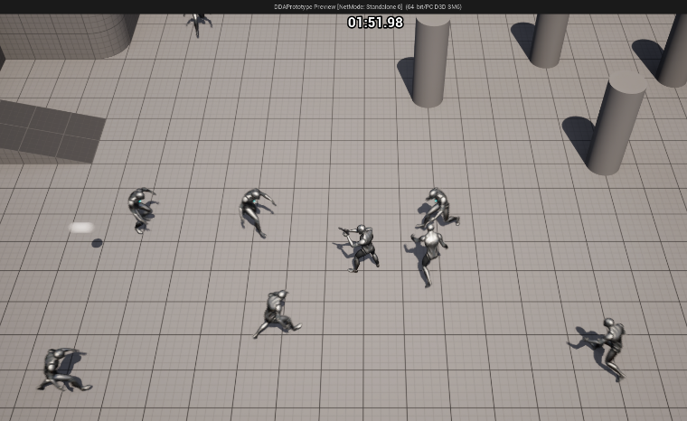
For testing purposes, I created a simple top-down game where players must survive for 2 minutes by shooting enemies. After implementing this game, I started working on the DDA. The biggest problem was saving reference points, as I didn't know how to do it with Unreal Engine. I wanted to provide a simple file where designers could write their points for consideration during gameplay. However, after investigation, I found that Unreal Engine does not allow reading data from separate files. I then started using data tables provided by Unreal Engine. After several hours of trying, it became clear that this only limited my idea. Data tables were restricted by their settings, and creating new types didn't solve my problems. In the end, I found that I could simply save settings inside the blueprint class and display them using C++ property metadata provided by Unreal Engine.
1. The screenshot from the game for POC. The player must survive 2 minutes while killing approaching enemies.
Once the problem with saving reference points and creating an interface was solved, I started implementing it in the game. A new problem arose regarding the design: how often should it recalculate player performance and how should it change during gameplay? To solve this, I added a timer that continually recalculates player performance and a separate function that adjusts game variables depending on the game difficulty. Additionally, I found a new way to calculate player performance based on reference points. Each reference point will have a value, and the final decision will be made based on these values. This approach solves the problem that occurs when a player performs well according to one variable but poorly according to another, ensuring the DDA works effectively. The variable with the higher value will determine the final decision.
To calculate player performance, we will use the formula from the research 'Exploring Dynamic Difficulty Adjustment in Videogame’s by Gabriel K. Sepulveda, Felipe Besoain, and Nicolas A. Barriga. We calculate the player's current performance (Cp) versus the expected player performance at that time (Ep[t]), which serves as our reference point. Performance = Cp/Ep[t]; In this manner, a value close to 1 indicates that the challenge is appropriate for the player. Gap margin defined by the game developer is necessary, as obtaining an exact value is unlikely. For example, setting the gap margin to 0.2 gives us a range of [0.8, 1.2]. This means that values lower than 0.8 indicate the game is too hard, while values greater than 1.2 indicate the game is too easy.
Lastly, we had a data collection problem. Luckily, this was easily solved by tracking all data according to time since all data was already available. Moreover, Unreal provides the ability to save text to a .txt file, so I used this to save gameplay data and allow designers to analyse it.
Finally, Proof of concept:
For testing purposes, I asked two students with different gaming backgrounds to participate. Student number 1 (Peter, [Image 3]) plays video games almost every day, while student number 2 (Edyta, [Image 2]) plays once per month. The skill gap between them is significant, and the DDA was supposed to maintain the flow channel for both players. The game was designed to be beatable after 2-3 tries but, most importantly, to provide a challenge. Both players were unaware that the game used DDA.
For testing, we kept the DDA as simple as possible. The game had 5 difficulty levels, and it considered player accuracy. The game difficulty represented the number of enemies spawned every 15 seconds. The more a player missed, the lower the game difficulty, and vice versa. (The shooting mechanic had a cooldown to prevent spam shooting.)
The first student won the game on the second try. His accuracy was 0.74, and the game difficulty increased from 2 to 4. [Image 5]
The second student won the game on the third try. Her accuracy was lower, as expected, at 0.48, and the game difficulty remained at 2 from the beginning to the end of the game. [Image 4]
Even though the skill gap between the two players was significant (as indicated by their accuracy), both players mentioned that the game was challenging enough, not boring, and not too hard. Moreover, student number one thought that the AI responsible for enemy spawning was trying to predict his movements. He did not realize that the number of enemies spawning increased, thinking instead that the difficulty was increasing only over time.
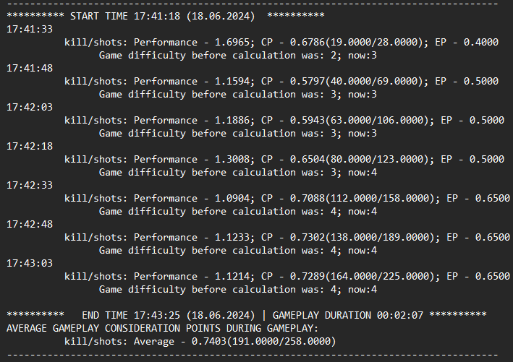
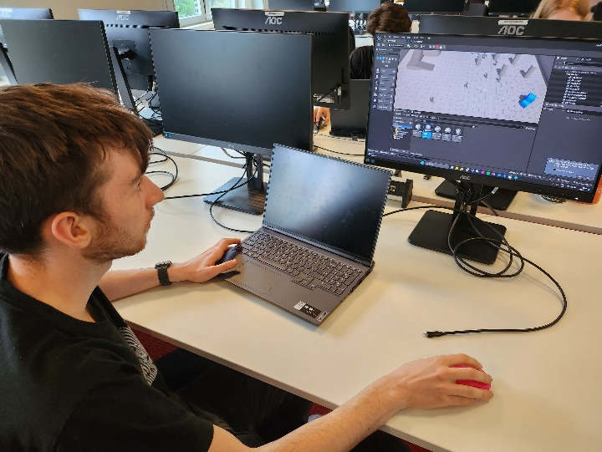
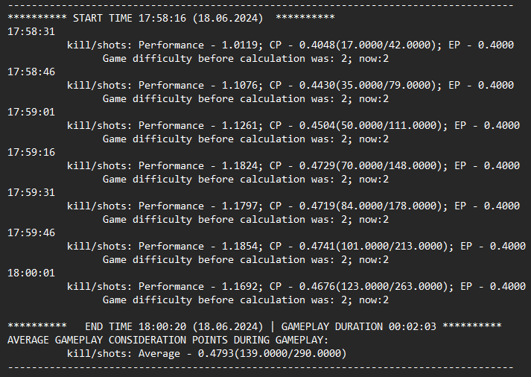
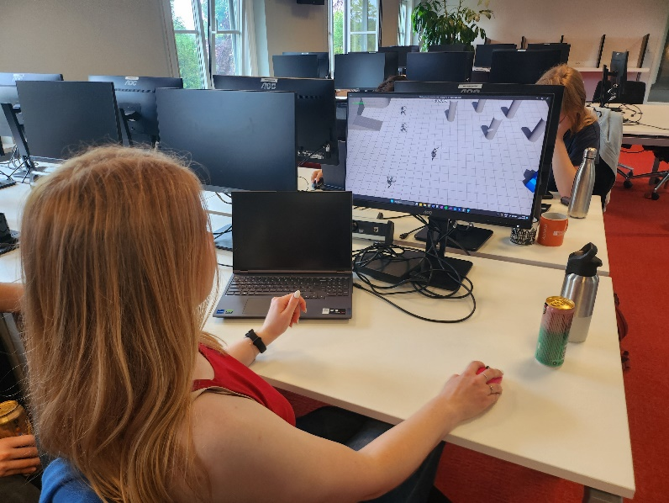
Image 2
Image 3
Image 4
Image 5
My Personal Feedback and Points for System Improvement:
The results from the test were better than I expected. It truly shows that DDA has potential in games and that it doesn’t require the old method of selecting difficulty levels. Moreover, it shows that even as the player progresses, the game can provide more challenges, preventing issues from an incorrectly chosen difficulty. A great benefit is that the player thinks the AI has its own mind, creating the illusion of "mind games with AI," even though it is just dynamically adjusting one parameter.
There were also points for improvement. Firstly, the game metrics I considered were great, but they may not be as easy to identify for larger games. After testing, I realized I could also use the distance at which enemies spawn from players as a metric, which could effectively change the game difficulty. Moreover, I understood that I should use variable averages for shorter periods rather than for the entire game. A player could perform poorly at the beginning and improve later, but if the overall average remains low, the game might become too easy. I need to add a new method to clean or differentiate some data points. Additionally, the lack of a clean interface may not be appreciated by designers, so I need to find a way to make it more user-friendly.
Reflection: The playtest went successfully; we obtained the results that I expected. Creating a gameplay data saver was a must for the playtest, as it helped to retain all necessary data during gameplay. However, in the future, it would be beneficial to involve more people in testing. With only two players, the results might not be entirely accurate.

POF in Unreal Engine
The POF already showed that this system works in Unreal Engine. However, to fully demonstrate its implementation, below will be evidence of how to set it up in Unreal:
To utilize my DDA system in Unreal Engine, the initial step involves compiling two C++ files for Unreal: DDA.cpp and GameplayDataSaver.cpp. After compilation, a new blueprint class named "DDA" should appear in Unreal Engine. This blueprint class is then placed within the game level.
Setup is straightforward and can be managed by designers. Firstly, under "DDA Settings," overall DDA parameters are configured, including calculation timers and the number of game difficulties. Secondly, "DDA Reference Points" are established to calculate player performance, where various metrics can be defined. The third section, "DDA Gameplay Adjustment Points," assigns values for game adjustments based on the game difficulty.
If set up correctly, the DDA system will function, and an automated process will generate a 'GameplayData.txt' file in the Unreal project folder, containing all collected gameplay data. It's important to note that GameplayData.cpp considers all Reference Points for saving, whether there is one or multiple points. The system handles everything automatically to provide accurate results.
For debugging purposes, I included two bool variables in "DDA Settings" to enable debug and UELOG messages. This helps identify setup errors, providing specific feedback on any misconfigurations.
Below, screenshots with setup examples.
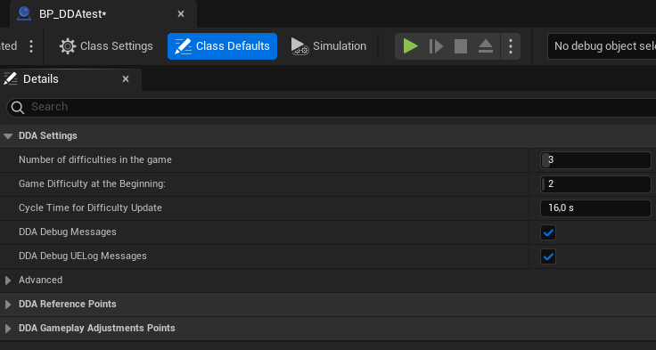
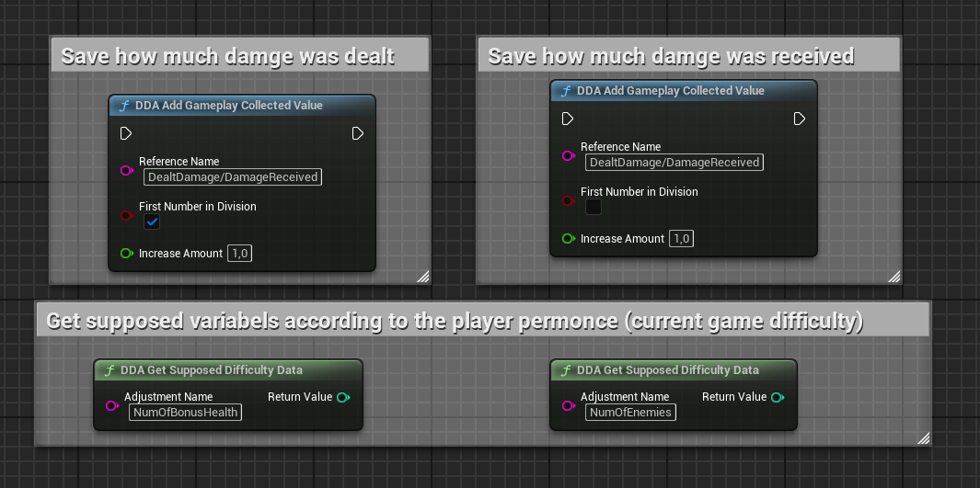
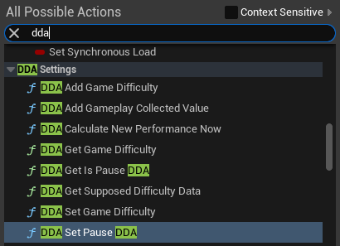
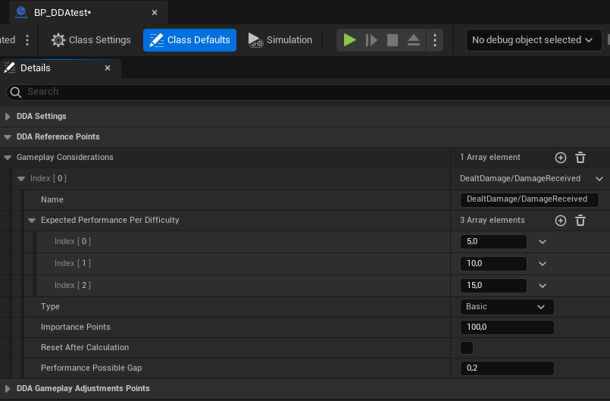
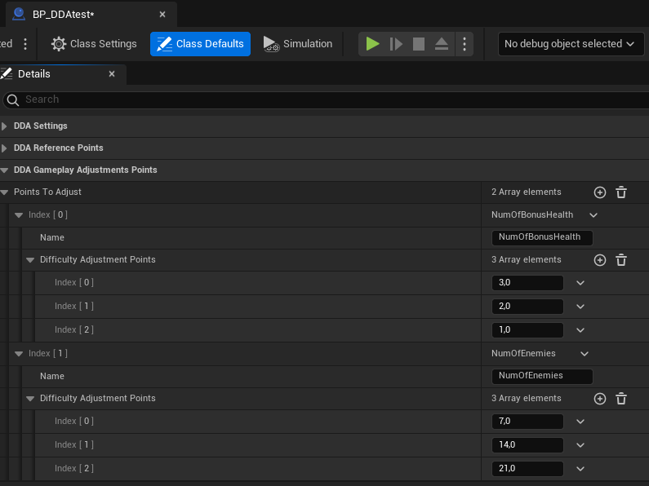
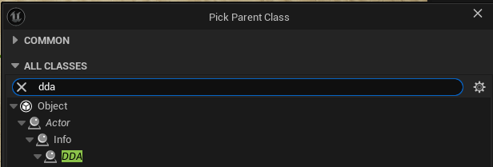
Reflection: I really like how it works in Unreal Engine. It automatically keeps track of an array list of points to consider and what should be changed with it. Handling it was great. However, the lack of documentation is not good. Some parts of the interface might be confusing, but due to time constraints, I didn't write proper documentation; I just explained everything in a team meeting with my DPs. Next time, I should definitely allocate time for writing documentation.

DDA in our project “Wasteland Walkers”
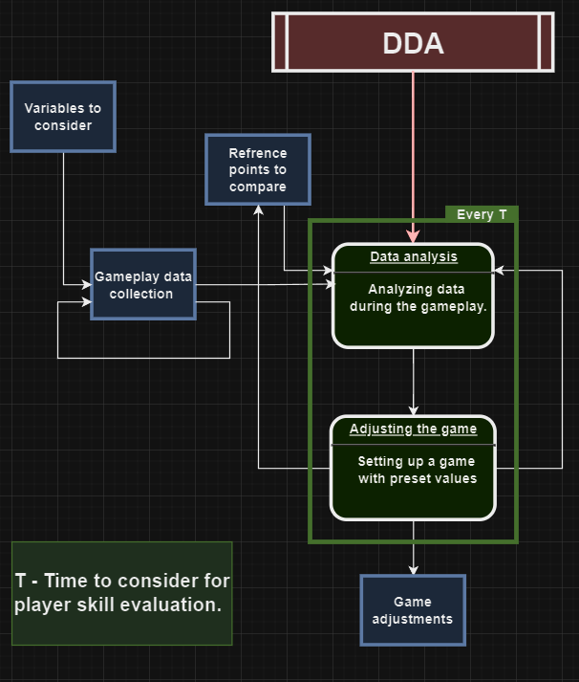
Integrating this technology into our game didn't pose a major challenge, but it did involve developing new functionalities. The DDA system calculated player performance levels at regular intervals (every x seconds), which posed challenges with our procedurally generated map. Players often explored the world extensively, potentially introducing unnecessary data that could lead to miscalculations.
Image 6. My DDA system's technical design
Designers wanted greater control over the DDA system. To address this, I implemented a feature allowing us to pause and un-pause the DDA timer or trigger immediate DDA calculations via function. For instance, DDA would adjust gameplay dynamics based on player performance metrics like damage taken only when players entered combat zones; once they left, DDA would pause. This approach ensured that gameplay difficulty remained stable during exploration outside combat scenarios and simplified debugging processes.
Reflection: It's crucial to maintain continuous communication with the team. While I made efforts in this regard, there were still gaps. Knowing in advance, I might have made the DDA timer an optional feature rather than mandatory. Nonetheless, I successfully integrated new features as per their requirements.

Conclusion and possible future improvements
Overall, my DDA system works in Unreal Engine, and I'm pleased with its successful implementation. However, there are several areas where the system could be improved:
- Considering External Player Data: Since our game was a cooperative game, asking for every player's data would not be a great idea. However, using information from accounts on different platforms would be a nice addition to the system, as it could be used for DDA calculations based on players' age, previous game experience, etc. This could lead to more accurate calculations.
- Handling Blueprint Functions in Unreal Engine: I could not find a way to solve the problem with Unreal Engine's limitation. For some blueprint DDA functions, it requires the name of the variable to be taken from an array list. Initially, I wanted to create a dropdown list for that so there would be no typos. However, it was not possible (or at least I don't know how to do it), since the list should be updated after compiling the variable inside the editor (in real-time), but Blueprint doesn't have this option. As an alternative, in my current system, errors will be generated if the name isn't exact.
- Documentation: DDA itself is a complex topic, and creating proper documentation for it is a time-consuming goal. Due to my priorities, I had to abandon this idea, but comprehensive documentation would make the system much easier and more usable for other developers.
In Conclusion: While DDA did not significantly impact our game due to time limitations and differing gameplay goals, it served as a valuable addition. Nevertheless, I believe DDA systems, not just mine, will play an integral role in future games. Such systems promise to enhance gameplay experiences for players of all ages and backgrounds, theoretically enabling enjoyable gameplay across diverse player profiles. Major game companies already leverage DDA to boost engagement and profitability, but it is important to balance game design with effective DDA implementation. Ultimately, integrating a properly configured DDA system can significantly benefit a game's overall experience, but only when the core game mechanics are well-established beforehand.

Used materials:
- Gabriel K. Sepulveda, Felipe Besoain, and Nicolas A. Barriga (2019) ‘Exploring Dynamic Difficulty Adjustment in Videogames’, https://www.researchgate.net/publication/339174028_Exploring_Dynamic_Difficulty_Adjustment_in_Videogames
- Andrew J.A. Seyderhelm and Karen L. Blackmore (2023) ‘How Hard Is It Really? Assessing Game-Task Difficulty Through Real-Time Measures of Performance and Cognitive Load’, https://journals-sagepub-com.buas.idm.oclc.org/doi/full/10.1177/10468781231169910
- Wikipedia, https://en.wikipedia.org/wiki/Dynamic_game_difficulty_balancing, (Accessed: 23 May 2024).

